Tree Summing
Time Limit: 1000MS |  | Memory Limit: 10000K
Total Submissions: 7938 |  | Accepted: 1845
Description
LISP was one of the earliest high-level programming languages and, with FORTRAN, is one of the oldest languages currently being used. Lists, which are the fundamental data structures in LISP, can easily be adapted to represent other important data structures such as trees.
This problem deals with determining whether binary trees represented as LISP S-expressions possess a certain property.
Given a binary tree of integers, you are to write a program that determines whether there exists a root-to-leaf path whose nodes sum to a specified integer. For example, in the tree shown below there are exactly four root-to-leaf paths. The sums of the paths are 27, 22, 26, and 18.
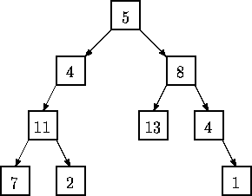
Binary trees are represented in the input file as LISP S-expressions having the following form.
empty tree ::= ()

tree ::= empty tree (integer tree tree)

The tree diagrammed above is represented by the expression (5 (4 (11 (7 () ()) (2 () ()) ) ()) (8 (13 () ()) (4 () (1 () ()) ) ) )
Note that with this formulation all leaves of a tree are of the form (integer () () )
Since an empty tree has no root-to-leaf paths, any query as to whether a path exists whose sum is a specified integer in an empty tree must be answered negatively.
Input
The input consists of a sequence of test cases in the form of integer/tree pairs. Each test case consists of an integer followed by one or more spaces followed by a binary tree formatted as an S-expression as described above. All binary tree S-expressions will be valid, but expressions may be spread over several lines and may contain spaces. There will be one or more test cases in an input file, and input is terminated by end-of-file.
Output
There should be one line of output for each test case (integer/tree pair) in the input file. For each pair I,T (I represents the integer, T represents the tree) the output is the string yes if there is a root-to-leaf path in T whose sum is I and no if there is no path in T whose sum is I.
Sample Input
22 (5(4(11(7()())(2()()))()) (8(13()())(4()(1()()))))
20 (5(4(11(7()())(2()()))()) (8(13()())(4()(1()()))))
10 (3
(2 (4 () () )
(8 () () ) )
(1 (6 () () )
(4 () () ) ) )
5 ()
Sample Output
yes
no
yes
no
Source
果然和今天上午做的 矩阵求和 很类似 尤其是 dfs 输入格式这一块 果然是相同的
他很巧妙的 去掉了第一个括号 利用了最后一个括号 而且 递归函数的参数选择选择的是高 很值得注意 如何选择有用的参数

这一题的两个if部分 感觉非常像dfs搜索的选择部分 他和矩阵求和还是不类似的 像真正的搜索题 选择部分 先左后右

5 (5()())
5 (5(5()())(6()()))
5 (5(5()()&(6()()&&
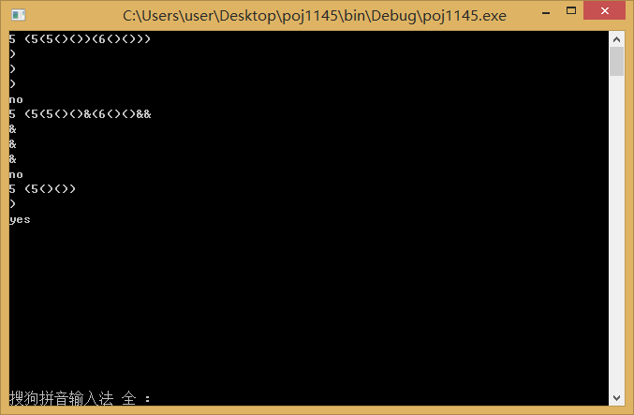

#include <iostream>
using namespace std;
int goal;bool flag;
char getnext()
{
char c;
while(cin>>c&&(c==' '||c=='\n'||c==9||c==10));
return c;
}
int dfs(int height,int sum)
{
int height1,height2;
char c;int k=0;int sign=1;
c=getnext(); //cout<<"ddd "<<c<<endl;
if(c==')') return height;//吸收前两个')'
if(c=='-')
{
sign=-1;
c=getnext();
}
while(c>='0'&&c<='9')
{
k=k*10+(c-'0')*sign;
cin>>c;
}
if(c==' '||c=='\n') c=getnext(); //cout<<"sad "<<c<<endl;
if(c=='(')
{
height1=dfs(height+1,sum+k); //cout<<sum+k<<endl;
}
// c=getnext();
c=getnext(); //cout<<"mark "<<c<<endl;
if(c=='(')
{
height2=dfs(height+1,sum+k);
}
c=getnext(); cout<<c<<endl; //这是吸收第三个')' 因为如果前两个dfs完成 他一定是第三个 是真正的结束点 因为最后一个')'就是在这里结束
if(height1==height+1&&height2==height+1)
{
if(k+sum==goal)
flag=true;
}
}
int main()
{
char c;
while(cin>>goal)
{
flag=false;
c=getnext(); //吸收了一个括号'(' 之所以要吸收是很关键的 因为只有他不符合递归形式
dfs(0,0);
//c=getnext(); cout<<c<<endl;
if(flag) cout<<"yes"<<endl;
else cout<<"no"<<endl;
}
return 0;
}

